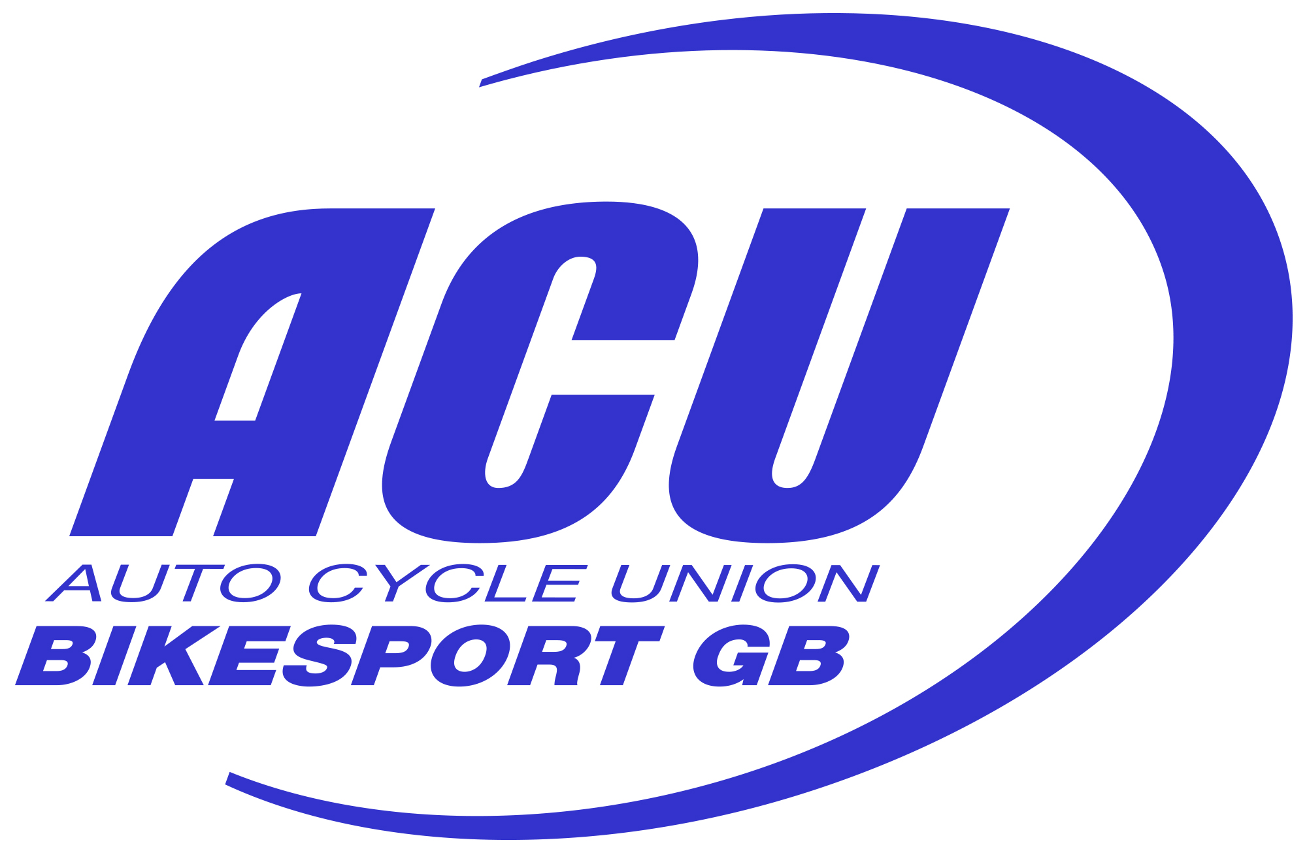
Frodsham District Trials Club

Affilliated to the Cheshire & North Wales Centre of the Auto Cycle Union Ltd

Alvanley Round 2 2025

Sunday 2nd March 2025 Permit No. ACU ???

Supplementary Regulations

Announcement - The Frodsham trials Club will be holding the above event on 02/03/25 which will be held under the National Sporting Code of the Auto Cycle Union, the Trials Standing Regulations, any applicable Trials Championship Regulations together with these Supplementary Regulations and any Final Instructions issued in accordance with TSR.21.

Status – Open

Eligibility - Riders must hold a current ACU Trials Registration Card or a SACU Licence.
One event licenses available Via Sport80

The event will include use of the Public Highway - No

Classes – Expert, Inters, Novice & Beginners Youth/Adult & twinshock

Entry Fee - £20 adult £10 youth

Venue – MOULDSWORTH SAND QUARRY CH3 8AN

What3Words = derailed.squeaking.humble

Start Time -. 10.30am

Course - Will consist of 4 laps of 10 sections. Unless this needs changing due to conditions on the day.

Method of Marking – In accordance with TSR22A

Entries – To be made

- Via Sport 80

Officials - ACU appointed Steward N/A Lic No.
Centre appointed Steward N/A Lic No.
Club appointed Steward N/A
Clerk of the Course Colin Steele Lic No.170565
Child Protection point of contact Sec of Meeting
Secretary of the Meeting Joanne Mackman
Address.Arboretum Cottage WA6 6XD Tel.07960088747
E-mail.ian@2machsmotorcycles.com

Additional Information

We will have the Scouts providing refreshment again this year so please support them as much as possible. Parking is tight at the venue so please follow marshals instructions.

